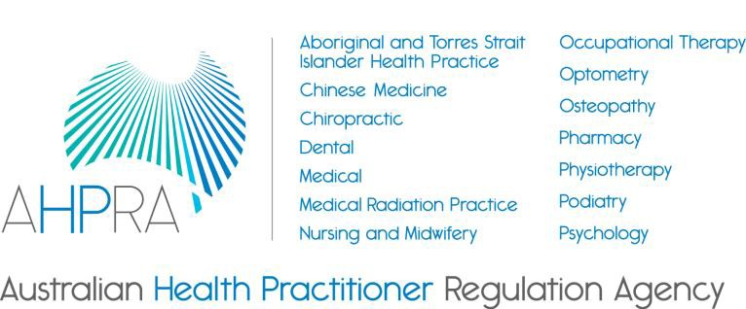

Communique
13 March 2018
Aboriginal and Torres Strait Islander health strategy group
National Boards, AHPRA and Accreditation Authorities have committed to an Aboriginal and Torres Strait Islander health strategy (the strategy) with the vision of:
Patient safety for Aboriginal and Torres Strait Islander peoples is the norm. We recognise that:

- patient safety includes the inextricably linked elements of clinical and cultural safety, and

- this link must be defined by Aboriginal and Torres Strait Islander Peoples.

To lead this important work, the Aboriginal and Torres Strait Islander health strategy group (the strategy group) has been established by AHPRA’s Agency Management Committee. Strategy group members include: Aboriginal and Torres Strait Islander health sector leaders and organisations, and representatives from Accreditation Authorities, National Boards, and AHPRA.
The strategy group is co-Chaired by Associate Professor Gregory Phillips, CEO of ABSTARR Consulting (front row, fifth from left) and Dr Joanna Flynn AM, Chair of the Medical Board of Australia (front row, fourth from left).
The group met for the fourth time on 13 March 2018 to refine components of the strategy and review strategic initiatives under implementation.
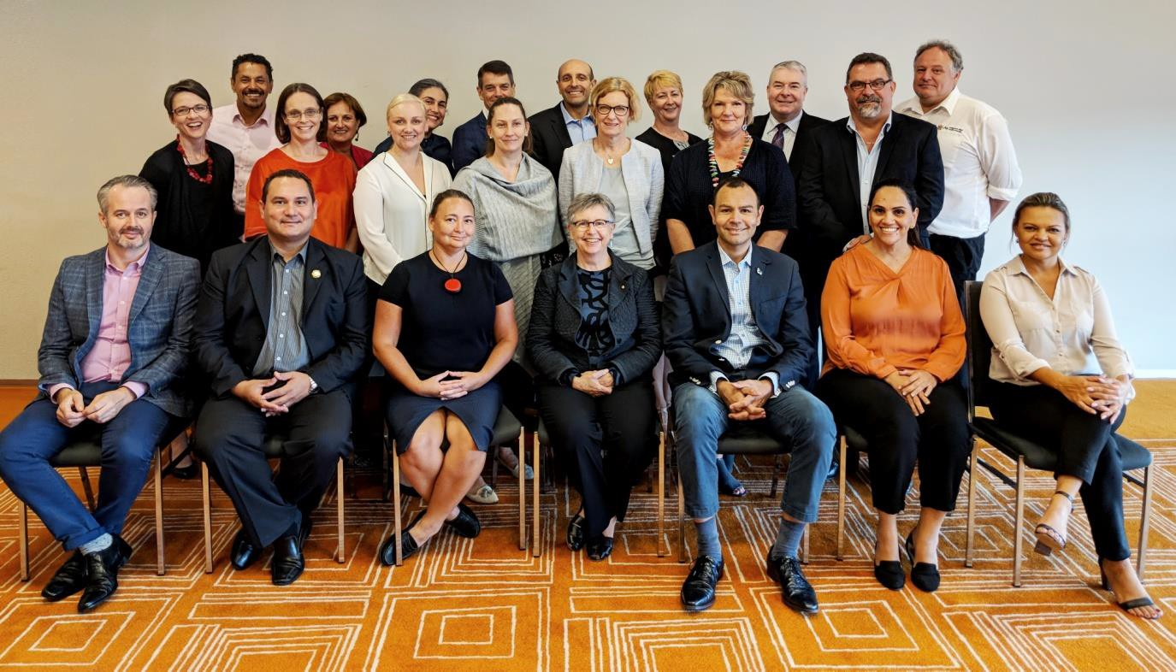
Image: Members of the strategy group taken at 13 March meeting (full list of attendees can be found at Table 1)

Decisions and actions

- Members endorsed the draft vision and values for the strategy and terms of reference for the strategy group.
- Members were updated on the work of two working groups:
  - working group on accreditation review and statement of intent provided a response to the State/Territory Jurisdictions’ Legislation Committee on the recognition of cultural safety for Aboriginal and Torres Strait Islander Peoples within the Health Practitioner Regulation National Law, as in force in each state and territory (the National Law). This response had input and approval from the strategy group, and
  - working group on cultural safety training drafted a cultural safety learning framework with draft scope, specifications and other identified procurement requirements. This framework will ensure the rollout of cultural safety training for all AHPRA staff, Board and Committee members and Accreditation Council/Committee members and staff. The strategy group endorsed the framework and recommended it to AHPRA’s financial delegate for approval.
- Accreditation representative, Ms Narelle Mills, presented to the group on the role of the accreditation function as a lever in realising the vision of the strategy.
- Members provided feedback on the draft Reconciliation Action Plan (RAP) for AHPRA and opportunities for the draft AHPRA Aboriginal and Torres Strait Islander employment strategy.
- The group discussed the major work required around three key strategic themes:

  - creating a culturally safe health workforce
  - increasing Aboriginal and Torres Strait Islander participation in the registered health workforce, and
  - creating greater access to the National Scheme for Aboriginal and Torres Strait Islander Peoples.

Next steps

In July 2018 the strategy group will celebrate the Statement of Intent, which is anticipated to be endorsed by 37 entities and has achieving equity in health outcomes between Aboriginal and Torres Strait Islander Peoples and other Australians by 2031 as its intent.
The AHPRA Reconciliation Action Plan (RAP) and Aboriginal and Torres Strait Islander Employment Strategy will continue to be progressed as planned.

Next meeting

The next meeting will be held in July 2018.

Table 1: Attendees and apologies

Attendees:
CEO, ABSTARR Consulting | Associate Professor Gregory Phillips
Medical Board of Australia Forum of NRAS Chairs | Joanna Flynn AM, Chair
Australian Indigenous Doctors' Association (AIDA) | Craig Dukes, CEO
Australian Indigenous Psychologists Association | Tanja Hirvonen, Executive Support Officer
Professor of First Peoples Health Griffith University | Professor Roianne West
National Aboriginal and Torres Strait Islander  Health Worker Association (NATSIHWA) | Karl Briscoe, CEO
Indigenous Allied Health Association (IAHA ) | Allan Groth (Proxy), COO
Australian Psychological Society | Sabine Hammond, Australian Indigenous Psychology Education Project (AIPEP)
Australian Indigenous Psychologists Association | Tania Dalton, Chairperson
Congress of Aboriginal & Torres Strait Islander Nurses and Midwives (CATSINaM) | Leonie Williamson (Proxy), Senior Policy Officer
Australian Health Practitioner Regulation  Agency | Chris Robertson, Executive Director, Strategy  and Policy
Australian Health Practitioner Regulation Agency | Eliza Collier, Northern Territory Manager
Australian Health Practitioner Regulation Agency | Jacqui Gibson, Community Reference Group member
Australian Health Practitioner Regulation Agency | Jill Humphreys, Executive Officer, Aboriginal and Torres Strait Health Practice
Australian Health Practitioner Regulation  Agency | Kym Ayscough, Executive Director, Regulatory  Operations
Australian Health Practitioner Regulation Agency | Martin Fletcher, CEO
Australian Health Practitioner Regulation  Agency | Michael Gorton AM, Chair, Agency  Management Committee
Pharmacy Board of Australia | Michael Piu, Community member
Chiropractic Board of Australia | Ailsa Wood, Board member
Occupational Therapy Board of Australia | Sally Cunningham (Proxy), Board member
Health Professions Accreditation Collaborative Forum | Narelle Mills, Member
Apologies:
SA Health and Medical Research Institute | Alex Brown, Director Aboriginal Health
Congress of Aboriginal & Torres Strait Islander Nurses and Midwives (CATSINaM) | Janine Mohamed, CEO (Proxy sent)
National Aboriginal Community Controlled  Health Organisation (NACCHO) | Pat Turner, CEO
Psychology Board of Australia | Marion Hale, Community member
Occupational Therapy Board of Australia | Julie Brayshaw, Chair (Proxy sent)
Health Professions Accreditation Collaborative Forum | Theanne Walters, Member
Lowitja Institute | Romlie Mokak, CEO
Inala Aboriginal Health Centre of Excellence | Noel Hayman, Clinical Director
Indigenous Allied Health Association (IAHA ) | Donna Murray, CEO (Proxy sent)
Aboriginal and Torres Strait Health Practice Board of Australia | Renee Owen, Chair
University of Wollongong | Ngiare Brown, Professor of Indigenous Health and Education
Australian Indigenous Psychologists Association | Pat Dudgeon, Vice Chair
Apunipima Cape York Health Council | Mark Wenitong, Director Medicine and Public  Health

