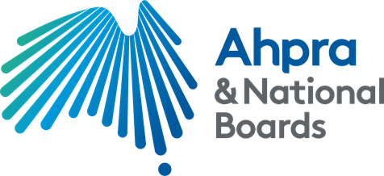

Health Profession Agreement

Nursing and Midwifery Board of Australia and
The Australian Health Practitioner Regulation Agency

2020-2025

Australian Health Practitioner Regulation Agency
G.P.O. Box 9958 | Melbourne VIC 3001 | www.ahpra.gov.au

Head Agreement

Preamble

The purpose of the Health Practitioner Regulation National Law (the National Law), as in force in each state and territory, is to establish the National Registration and Accreditation Scheme (the National Scheme). The National Scheme has six key objectives set out in s.3(2) of the National Law. In summary, the objectives are to:
- protect the public
- facilitate workforce mobility for health practitioners,
- facilitate high-quality education and training of health practitioners,
- facilitate assessment of overseas-trained health practitioners,
- facilitate access to health services, and
- development of a flexible, responsive and sustainable health workforce.
In accordance with the 2019 policy directions from the Council of Australian Governments (COAG) Health Council, the protection and safety of the public is the paramount consideration when administering the National Scheme.

Fifteen National Boards and the Australian Health Practitioner Regulation Agency (Ahpra) work in partnership to deliver these objectives, as well as the objectives of the National Scheme Strategy 2020-2025. Ahpra and National Boards have clear accountabilities for the separate and shared functions that contribute to achieving these objectives.

This Health Profession Agreement (HPA) is a statutory instrument under the National Law. Under the National Law, the Nursing and Midwifery Board of Australia (the National Board) and Ahpra are required to negotiate in good faith and attempt to come to an agreement on the terms of the HPA. Although the National Board does not have the power to enter into contracts generally (s.32(2)(a)), the National Law clearly intends that the Board will agree and execute an HPA with Ahpra.

Accountability Framework

The National Scheme Accountability Framework (the Accountability Framework) is at Schedule 1 to this HPA. It defines the accountabilities of all relevant entities in the National Scheme arising from their functions under the National Law.

The Accountability Framework is an essential foundational document for the partnership between Ahpra and National Boards as articulated by this HPA, as well as the exercise of delegated functions under the National Law.

The Accountability Framework will be reviewed annually by Ahpra and the Board in line with the other HPA schedules. However, to ensure the effective delivery of functions of the National Scheme, any updates or changes to the Accountability Framework require the agreement of Ahpra and all National Boards.

Purpose of this Agreement

The purpose of this HPA is to make provision for the following, as outlined in s 26(1) of the National Law:

- the fees payable by health practitioners and others in relation to the health profession for which the National Board is established,
- the National Board’s annual budget, and
- the services to be provided to the National Board by Ahpra to enable the National Board to carry out its functions under the National Law.
This HPA also describes the relationship between the National Board and Ahpra, where Ahpra is both a governance and regulatory partner, as well as a service provider to the National Board. As such, it

outlines how both Ahpra and the National Board, as statutory entities, work together to achieve the goals of the National Scheme.

Behavioural Attributes

In line with the values articulated in the National Scheme Strategy, the National Board and Ahpra agree to the following behavioural attributes, the purpose of which is to provide guidance to each party in exercising its responsibilities under this HPA:
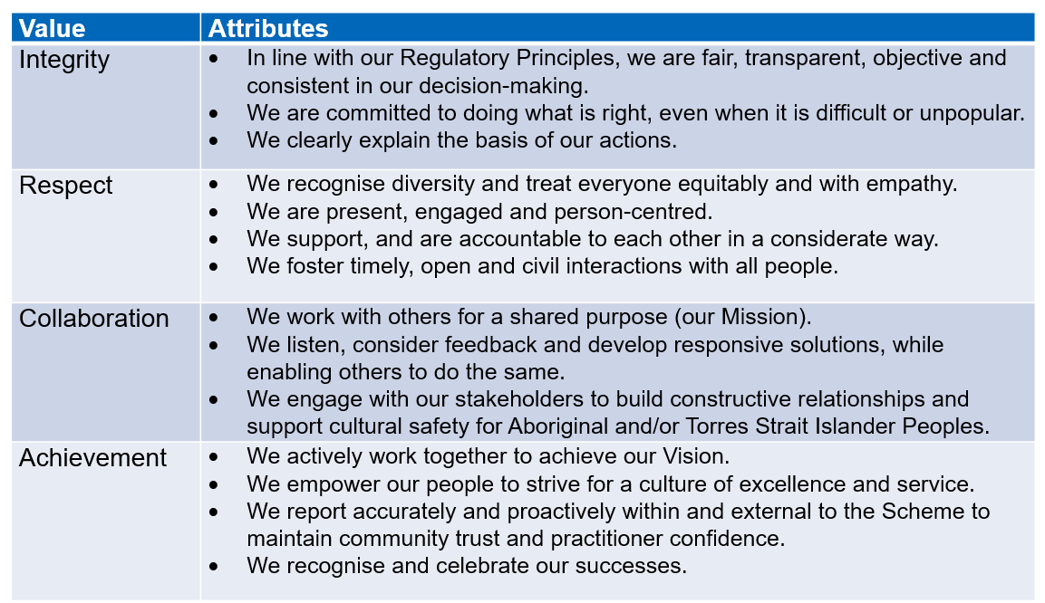

Period

This HPA is for the period 1 July 2020 to 30 June 2025 inclusive.

Liaison Officers

The National Board agrees to authorise the Chair of the National Board (or his/her nominee) to act as liaison officer with respect to the HPA. Ahpra agrees to authorise the Executive Director, Strategy and Policy to act as liaison officer with respect to the HPA.

Schedules
The following table outlines how the requirements of s. 26(1) of the National Law are represented in the HPA schedules, as well as describing the content of all other schedules.

Schedule 1: Accountability Framework
Schedule 2: Summary of Services to be provided to the National Board by Ahpra to enable the National Board to carry out its functions
Schedule 3: Summary of National Scheme Strategy, implementation map, and National Board’s regulatory plan
Schedule 4: Fees payable by health practitioners Schedule 5: Summary of National Board’s annual budget Schedule 6: Performance and Reporting
Schedule 7: Equity Framework

The Performance and Reporting framework contained in Schedule 6 provides the mechanism for articulating performance metrics for the purposes of this HPA.

National Scheme Strategy 2020-25

The National Scheme Strategy outlines the shared vision, mission, values and strategic objectives for Ahpra and the National Boards.

Together, Ahpra and National Boards are focused on ensuring the effective implementation of our strategy including supporting and promoting our four strategic themes of regulatory effectiveness, capability and culture, evidence and innovation, and trust and confidence.

Issues management and escalation
Issues management and escalation provides a means to identify, track and resolve partnership issues throughout the life of the agreement ensuring each issue is resolved quickly and effectively between Ahpra and the Board.

An issue is defined as any problem or concern that has the potential to adversely affect the success of the partnership between Ahpra and the Board.

In line with our shared values, Ahpra and the National Board will work constructively to identify and resolve issues in a timely way and at the lowest possible level. Ordinarily, this will be achieved by discussion or negotiation between the relevant Executive Officer, the Chair/nominated National Board member and any other relevant Ahpra senior staff (generally at the level of a National Manager) with responsibility for a relevant functional area (e.g.: registrations, policy etc.).

In the event an issue remains unresolved, at the operational level it must be escalated in accordance with Ahpra reporting lines, to either the Executive Director, Strategy and Policy or the National Director, Regulatory Governance who will take reasonable steps to facilitate resolution of the issue to the satisfaction of Ahpra and the National Board.

In the event an issue needs to be escalated further, it will be escalated to the appropriate member(s) of Ahpra’s National Executive, the Chair of the Agency Management Committee and/or dealt with as a dispute below.

Dispute resolution

The National Board and Ahpra have a commitment to working together constructively and in accordance with our shared values to reasonably prevent any issues escalating into disputes.

For the purposes of this HPA, a dispute is defined as any unresolved disagreement between the Board and Ahpra about the terms or schedules, including the performance of either party, of this agreement.

If a dispute arises, as partners, we will use our best endeavours to resolve the dispute respectfully, fairly and promptly.
If the dispute cannot be resolved, the matter will be referred to the Ahpra Chief Executive Officer and the Chair of the National Board. If the dispute still cannot be resolved, it will be referred to the Chair of Ahpra’s Agency Management Committee and the Chair of the National Board.

Either the Chair of Ahpra’s Agency Management Committee or the Chair of the National Board may request the appointment of an independent, accredited mediator at any stage in the process. The process for appointment is for both parties to agree to the appointment of the nominated mediator.

If we are still unable to agree on the matter, s. 26(2) of the National Law provides that any failure to reach agreement between National Boards and Ahpra on matters relating the HPA is to be referred to the Ministerial Council (as that term is defined in the National Law) for resolution. The National Board and Ahpra agree that this is a step of last resort that will not be taken unless all prior steps have been exhausted.

Review

The National Board and Ahpra agree to review the HPA head agreement at least every five years in line with the review of the National Scheme Strategy, or earlier with the agreement of all National Boards and Ahpra.

The supporting schedules will be reviewed and agreed annually by Ahpra and the National Board.

Publication

Once agreed, both the HPA head agreement and schedules will be published on the Ahpra and the National Board websites respectively.

This Agreement is made between

Nursing and Midwifery Board of Australia

and

The Australian Health Practitioner Regulation Agency (Ahpra)

Signed for and on behalf of Ahpra by: | Signed for and on behalf of the Nursing and Midwifery Board of Australia by:
Signature of Chief Executive Officer | Signature of the Board Chair
Mr Martin Fletcher | Associate Professor Lynette Cusack
Date 04 September 2020 | Date 01 October 2020

Schedule 1: Accountability Framework

National Registration and Accreditation Scheme Accountability Framework v.1.8 (November 2019)
All entities in the National Registration and Accreditation Scheme (the National Scheme) are ultimately accountable to the public through the Ministerial Council. The agreement between Australian Governments on the design of the National Scheme creates interdependent statutory authorities with no single point of accountability for all National Scheme functions. The Health Practitioner Regulation National Law Act, as enacted in each State and Territory (the National Law) creates the legal basis for the National Scheme.
As a key component of the overall governance arrangements, this framework articulates the accountabilities of key entities arising from their roles and functions in the National Scheme. Ahpra, its governing Board (the Agency Management Committee (AManC), the National Health Practitioner Boards (National Boards) and their accreditation authorities are all entities created by National Law. Their powers and functions are prescribed in the National Law, the Health Practitioner Regulation National Law Regulation 2018 (National Law Regulation) or otherwise, conferred by applicable legislation. However, accountabilities for National Scheme entities also arise from statutory instruments, including policy directions from the Ministerial Council and from statutory agreements or other negotiated agreements.

External agencies, contractors or consultants cannot be held directly accountable for delivering the functions of an entity under the National Law. The mechanism for assigning responsibility for such functions is the contract or agreement that governs the provision of services. Under the National Law, only Ahpra can enter into contracts with external entities and accountability as to the management of the contract rests with the delegate approving the contractual arrangements.

Accountability can be delegated by an accountable person or entity to another person or entity. This framework is also designed to support the exercise of delegations in the National Scheme under section 37 and schedule 7 section 29 of the National Law. As a general principle, decision-making within Ahpra is delegated to the lowest reasonable level, having regard to the knowledge, experience and capabilities required to exercise the responsibility. Delegators must specify any conditions or limitations placed on the exercise of delegated powers and functions. For example, if a health profession National Board requires assurance that a decision will only be made with appropriate clinical input, this can be specified in the Instrument of Delegation to Ahpra. Ahpra is then responsible to ensure compliance with that specification when exercising the responsibility.

The Health Profession Agreement (section 26 of the National Law) with each National Board codifies the relationship with Ahpra as both a governance and regulatory partner and service provider.

Visual representation of accountability
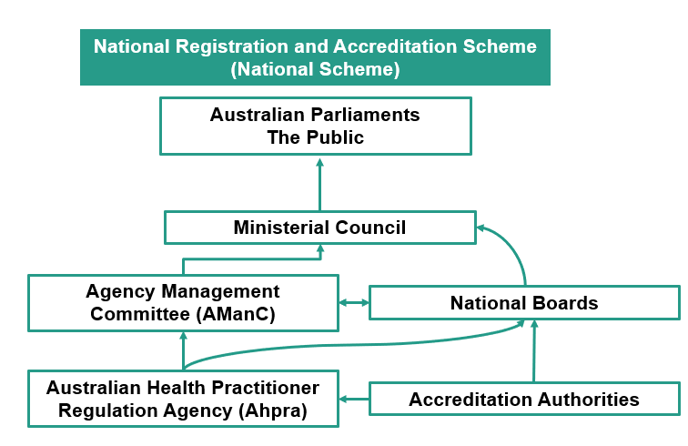

The Ministerial Council is ultimately accountable for the National Scheme
Ultimate accountability for the performance of the National Scheme resides with the parliaments of each State and Territory of Australia, through the Ministerial Council. Under the National Law, the Ministerial Council may provide policy directions to Ahpra and the National Boards, approve registration standards, make regulations and approve certain other recommendations from National Boards in respect of specialist registration, or endorsements on registration. The Ministerial Council is also accountable for appointing the AManC and National Boards and can remove appointed members in specific circumstances. The annual report provided to the Ministerial Council and tabled in each Parliament is a key component of how Ahpra and National Boards are accountable to the Ministerial Council and parliaments.

The Agency Management Committee (AManC) is accountable for National Scheme performance
As the governing board for the National Scheme, AManC has a principal role in the approval, monitoring and reporting of performance of the National Scheme strategy as well as directing and controlling the affairs and policy directions of Ahpra. The AManC is accountable for National Scheme performance, including the establishment of regulatory procedures and general administration of the National Scheme. To enable it to perform its executive functions, Ahpra has powers to employ staff and enter into contracts.
Accountable to all Australian Parliaments, the Ministerial Council, the justice system, Administrative and Regulatory bodies for:  - all acts and things done by Ahpra.  - corporate governance, including Workplace Health and Safety for all physical and virtual work locations controlled by Ahpra.  - operational performance of the National Scheme.  - delivering Ahpra functions required by the National Law, including specific regulatory powers under Part 7.  - oversight and leadership on significant whole of scheme accreditation issues, including governance, accountability and transparency issues.  - compliance with relevant obligations set by other regulators.  - financial management in relation to the administration of the Agency Fund.  - appointment of the CEO, conferral of powers and delegations to the CEO. | Accountable to National Boards for:  - setting, monitoring and reviewing performance of the National Scheme Strategy.  - services provided by Ahpra to enable the Board to carry out its regulatory functions, including finance and communications.  - executing and managing contracts with accreditation authorities on the advice, and with approved terms and conditions, from the relevant National Board.  - executing and managing contracts for services with external providers on the advice, and with approved terms and conditions, from the relevant National Board.  - ensuring that Ahpra's operations are carried out efficiently, effectively and economically.

The Chief Executive Officer is accountable for the delivery of Ahpra’s functions
The Chief Executive Officer is accountable for delivery of Ahpra’s functions through an employment contract with and delegated authority from the AManC. The CEO also has a partnership responsibility with each National Board under the Health Profession Agreements.
Accountable to the Agency Management Committee for:  - implementing the National Scheme Strategy.  - delivery of Ahpra functions including specific regulatory powers under Part 7.  - delivery of services to National Boards.  - conferral and exercise of delegated functions by Ahpra. | Accountable to National Boards and their committees for:  - Effective, efficient and economic delivery of regulatory procedures and services consistent with the Health Profession Agreements.

National Boards are accountable as the principal regulatory decision-makers
National Boards are the principal regulatory decision-makers in the National Scheme, with delegated functions undertaken by Ahpra and by their committees including, where relevant, State, Territory or Regional Boards. National Boards are accountable to the Ministerial Council and Australian Parliaments for regulatory policies, the quality of their regulatory decisions, and through the court system and relevant administrative review bodies for the legality of their regulatory decisions. While National Boards can propose regulatory procedures, they do not establish or administer them.
Without the power to employ staff or enter into contracts, National Boards rely on the partnership with Ahpra for the services provided under the HPAs.
Accountable to the Ministerial Council and Australian parliaments for:  - proper exercise of functions under National Law, including regulatory policies and the quality of their regulatory decisions. | Accountable through the justice system, administrative and regulatory bodies for:  - the legality of regulatory decisions, including by delegates. This can also include adequacy of standards, codes, guidelines, delegations and probity of decision- making processes. | Accountable to the AManC for:  - partnership responsibilities with Ahpra under the HPA, including provision of information to enable Ahpra to perform its financial management functions.  - informing and supporting the development of the National Scheme Strategy

Accreditation Authorities are accountable for the delivery of specific accreditation functions.
An accreditation authority may be an external entity, or a committee established by a National Board. The National Law creates a ‘separation of powers’ between National Boards and accreditation authorities by clearly specifying distinct decision-making roles in accreditation functions. Ahpra formalises arrangements for performance and funding of accreditation functions through contracts with external entities and terms of reference (TOR) for committees. Ahpra has facilitated the development of standardised agreements and TORs incorporating performance metrics and developed a cross- profession reporting model for accreditation authorities. These provide an overarching reference document for National Boards and Ahpra to assess the work of accreditation authorities.
Accountable to National Boards and their committees:  - the performance of accreditation functions as described in the contract with Ahpra or the relevant ToR. | Accountable to Ahpra for:  - delivery of funded accreditation activities, including compliance with performance measurement processes and reporting obligations, through an accreditation contract with Ahpra, or an approved ToR, on behalf of the National Board.

Schedule 2: Summary of services to be provided to the National Board by Ahpra to enable the National Board to carry out its functions
In the event of any exceptional circumstances, outside of the annual review of schedules, any changes to Schedule 2 will be negotiated with National Boards.

Regulatory services, procedures and processes

1. 1 Registrations
Core | Profession Specific
1.1.1 Develop, implement and regularly review nationally consistent procedures for the registration of health practitioners | Profession-specific services, as listed in the National Board’s regulatory plan and annual budget.
1.1.2 Manage practitioner registration, renewal and audit
1.1.3 Maintain a public register of health practitioners
1.1.4 Maintain a register of health practitioner students
1.1.5 Provide an online registration services to health practitioners
1.1.6 Support the National Boards in the operation of examinations
1.1.7 Maintain list of approved programs of study for all professions

1.2 Notifications
Core | Profession Specific
1.2.1 Develop, implement and continuously improve nationally consistent risk assessment procedures | Profession-specific services, as listed in the National Board’s regulatory plan and annual budget.
1.2.2 Manage the end to end notification process ensuring legality, efficiency, effectiveness and continuous improvement
1.2.3 Engage clinical advisors to enhance Ahpra’s understanding of profession specific issues that impact safe, professional practice
1.2.4 Establish and maintain relationships with co-regulatory authorities, indemnity providers and other stakeholders with an interest in ensuring safe delivery of health care to patients

1.3 Compliance
Core | Profession Specific
1.3.1 Review, implement and continuously improve nationally consistent compliance policy, processes and systems | Profession-specific services, as listed in the National Board’s regulatory plan and annual budget.
1.3.2 Manage practitioners with registration restrictions (conditions and undertakings), suspension or cancellation
1.3.3 Undertake the intake and assessment of offence complaints, assessment of all advertising offence complaints and the ongoing management of low and moderate risk advertising complaints under the Advertising Compliance and Enforcement Strategy.
1.3.4 Manage the development and maintenance of the National Restrictions Library
1.3.3 Oversee the ongoing development and reporting of performance measures for monitoring of practitioner’s compliance

1.4 Legal Services
Core | Profession Specific
1.4.1 Provide nationally consistent legal advice and management to support effective and lawful registration, notifications and compliance procedures, and hearing panels processes | Profession-specific services, as listed in the National Board’s regulatory plan and annual budget.
1.4.2 Conduct all Tribunal and court matters involving Ahpra and the National Boards
1.4.3 Provide legal advice and services to the Boards to enable it to effectively and efficiently perform its functions and meet its objectives.
1.4.3 Defend and/or resolve any litigation brought against the Board and respond to complaints lodged with external bodies against the Boards.
1.4.4 Respond to FOI requests, summonses, subpoenas and other compulsory processes issued to National Boards or in respect of National Board activities.
1.4.5 Ensure National Boards are compliant with all legislative requirements

- Regulatory Governance

2.1 Governance and regulatory advice
Core | Profession Specific
2.1.1 Develop and administer procedures to support effective and efficient National Board and committee operations | Profession-specific services, as listed in the National Board’s regulatory plan and annual budget.
2.1.2 Support the development and implementation of National Board Regulatory Plans, including regular reporting
2.1.3 Provide National Board member orientation, induction, professional development and evaluation programs
2.1.4 Develop and release National Board communiqués, National Board newsletters and news updates
2.1.5 Support working relationships with relevant committees

2.2 National Board Services
Core | Profession Specific
2.2.1 Provide secretariat and administrative support for National Board Meetings | Profession-specific services, as listed in the National Board’s regulatory plan and annual budget.
2.2.2 Provide secretariat and administrative support for National Board committee meetings
2.2.3 Provide panel hearing secretariat support
2.2.4 Secretariat and policy support for governance forums, including the Forum of Chairs and its sub-committees
2.2.5 Provide support in the recruitment of members to National Board committees and the List of Approved Persons for panels as requested by National Boards.

- Engagement and Government Relations

3.1 Communication
Core | Profession Specific

3.1.1 Develop, implement and review communication strategies, tools and guidelines | Profession-specific services, as listed in the National Board’s regulatory plan and annual budget.
3.1.2 Review and release National Board media releases
3.1.3 Develop and maintain National Board website and resources
3.1.4 Coordinate and manage the production of the Ahpra and National Board annual report and other publications
3.1.5 Provide communications advice and support for crisis and issue management
3.1.6 Develop Branding for National Board and Ahpra Communication
3.1.7 Report on relevant media coverage
3.1.8 Monitor and manage social media

3.2 Engagement
Core | Profession Specific
3.2.1 Build trust and confidence with external stakeholders, consistent with the National Scheme’s strategies on engagement | Profession-specific services, as listed in the National Board’s regulatory plan and annual budget.
3.2.2 Manage government relations, including advice and reporting to governments and Ministers, corporate secretariat, WHO Collaborating Centre
3.2.3 Undertake consultation to support National Board strategies and guidelines
3.2.4 Engage with external advisory groups as needed
3.2.5 Monitor, support and advise on stakeholder engagement activities

- Strategy

4.1 Development
Core | Profession Specific
4.1.1 Inform and support the development and annual review of the National Scheme Strategy | Profession-specific services, as listed in the National Board’s regulatory plan and annual budget.
4.1.2 Provide resources and support to assist with National Board
regulatory planning
4.1.3 Coordinate the annual review, development and execution of the Health Professions Agreements with Ahpra

4.2 Implementation
Core | Profession Specific
4.2.1 Promote and ensure organisational alignment to the National Scheme Strategy. | Profession-specific services, as listed in the National Board’s regulatory plan and annual budget.
4.2.2 Promote and ensure management oversight for effective delivery of scheme-level strategic initiatives.
4.2.3 Deliver regular HPA and strategy performance reports.

- Policy

.
5.1 Policy
Core | Profession Specific
5.1.1 Maintain procedures for the development of registration standards, codes, policies and guidelines | Profession-specific services, as listed in the National Board’s regulatory plan and annual budget.
5.1.2 Develop, review, consult on and implement cross-profession standards, codes and guidelines
5.1.3 Assist National Boards to develop, review and implement cross- profession regulatory policy and profession specific policy
5.1.4 Provide tools to support regulatory policy development, review and evaluation
5.1.5 Coordinate work on whole of Scheme, cross-directorate and profession specific regulatory policy issues

5.2 Accreditation
Core | Profession Specific
5.2.1 Support National Boards to oversight effective delivery of accreditation functions | Profession-specific services, as listed in the National Board’s regulatory plan and annual budget.
5.2.2 Support accreditation committees to deliver the accreditation functions, where applicable
5.2.3 Maintain procedures for the development of accreditation standards
5.2.4 Coordinate work on whole of Scheme and multi- profession accreditation policy issues.

5.3 Research
Core | Profession Specific
5.3.1 Develop and implement an annual National Scheme research and evaluation plan | Profession-specific services, as listed in the National Board’s regulatory plan and annual budget.
5.3.2 Work with National Boards to identify priority cross-profession issues.
5.3.3 Provide advice and consult with National Boards about proposed research and evaluation projects and develop supporting tools and training
5.3.4 Broker, participate in and maintain strategic data and research partnerships with external organisations
5.3.5 Develop and regularly update a research governance framework and evaluation methodologies

5.4 Data
Core | Profession Specific
5.4.1 Develop, implement and manage the process and procedures for data access, release and exchange | Profession-specific services, as listed in the National Board’s regulatory plan and annual budget.
5.4.2 Develop and maintain core data and statistical infrastructure to support internal and external research and analyses
5.4.3 Implement processes to improve the quality of our data to ensure it is fit for purpose

5.5 Finance
Core | Profession Specific
5.5.1 Provide analysis, support and advice on financial plans, fee setting and annual budgets | Profession-specific services, as listed in the National Board’s regulatory plan and annual budget.
5.5.2 Make provision for fees payable by health practitioners
5.5.3 Develop and maintain the Equity model
5.5.4 Manage equity investments in accordance with the conservative approach required of the Investment Policy
5.5.5 Develop and maintain the cost allocation model used to inform the apportionment of Ahpra’s costs
5.5.6 Discretionary/initiative project evaluation, monitoring and benefits reporting
5.5.7 Provide stage-gated financial reporting for major Scheme-wide projects1 to assess progress and validate readiness for the next stage.

5.6. Risk management
Core | Profession Specific
5.6.1 Coordinate the development of Board level profession risk assessments and plans | Profession-specific services, as listed in the National Board’s regulatory plan and annual budget.
    - Review and implement all necessary insurances including, but not limited to:
      - Professional Indemnity
      - Directors and Officers
      - Crime
      - Cyber Liability
      - Business Travel
      - Workers compensation
      - Corporate Practices Protection
      - Industrial Special Risk
5.6.3 Business continuity planning, preparation, response and recovery approaches for any form of critical incident

1 Major projects are those classified as high value and high risk to the National Scheme and will generally require a detailed business case. For these projects, at each Stage Gate, a review is undertaken assessing the project against its specified objectives at the particular stage in the project’s life cycle, identifying early the areas that may require corrective action and validating that a project is ready to progress successfully to the next stage.

Schedule 3: Summary of National Scheme Strategy, implementation map, and National Board’s regulatory plan

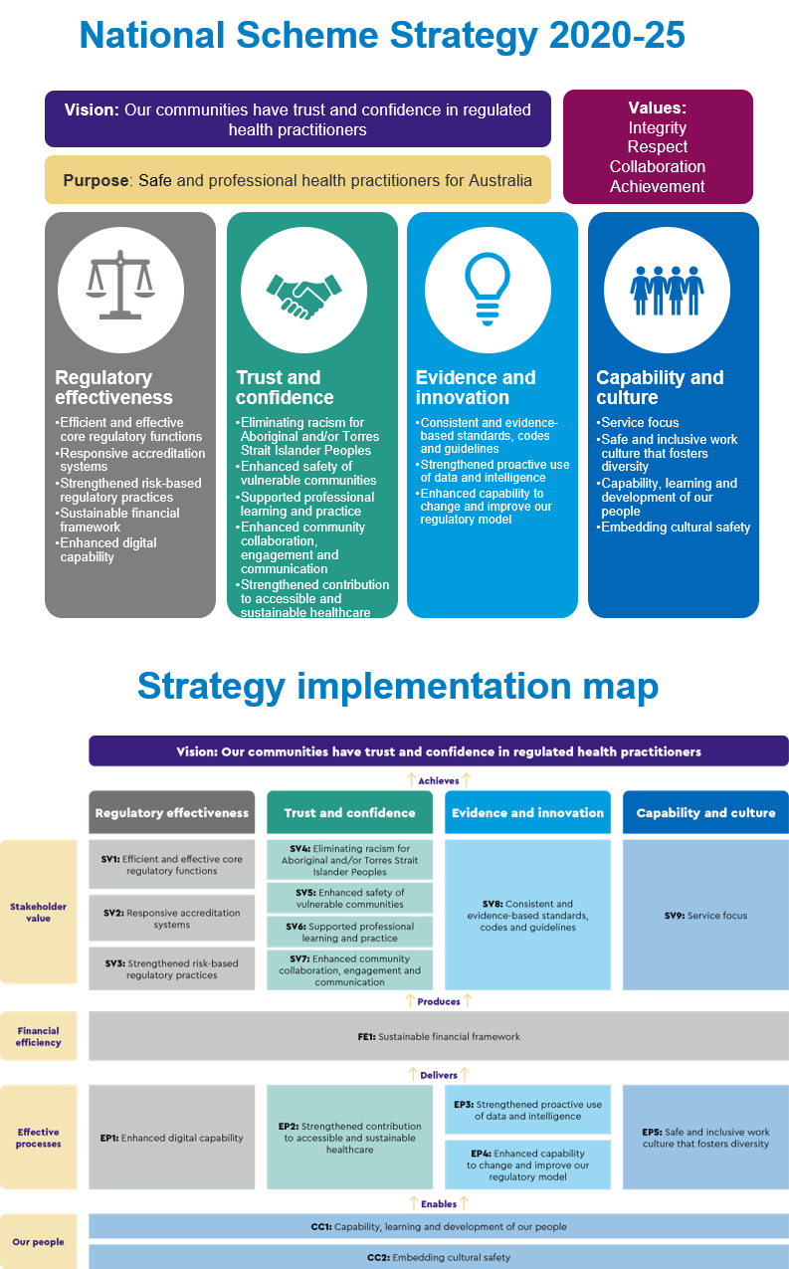
Regulatory Plan 2021-2025
Effective 1 July 2021 (updated August 2022)
National Scheme strategic theme | Strategic outcomes | Related NMBA initiatives
Regulatory effectiveness | SV1: Efficient and effective core regulatory functions  SV2: Responsive accreditation systems  SV3: Strengthened risk-based regulatory practices  FE1: Sustainable financial framework  EP1: Enhanced digital capability | To deliver responsive accreditation systems for approved nursing and midwifery programs of study
 |  | Educating the nurse of the future – National assessment tool for preregistration RNs (NATPRN) | Development of a national assessment tool for the assessment of students in NMBA-approved pre-registration registered nurse programs of study (student RNs) against the knowledge, skills and attributes articulated in the NMBA Registered nurse standards for practice  Joint project with ANMAC (SV2)
 |  | Educating the nurse of the future – Quality clinical placements | Review of the current clinical professional experience placement (PEP) landscape and develop a framework/suite of products designed to improve the quality and national consistency of PEP for students of NMBA-approved programs of study leading to registration as a nurse and/or midwife or as endorsement as a nurse practitioner  Joint project with ANMAC (SV2)
 |  | To implement strengthened risk-based regulatory practices to support safe and effective delivery of care by nurses and midwives
 |  | Disability Royal Commission | Implementation of relevant recommendations following final outcomes from Royal Commission into Violence, Abuse, Neglect and Exploitation of People with Disability (SV3)
 |  | International regulators | Involvement and consultation with any projects identified and commenced by international regulatory partners including ongoing involvement in the International Nurse Regulator Collaborative (INRC) project Feasibility of developing regulatory mechanisms to support mobility of nurses across the INRC member jurisdictions (SV3)
 |  | Accurate database of students | Refinement of the student register to create an accurate database of current students in all programs of study to inform  - improved workforce planning  - improved management of students  - improved engagement  (SV1, SV3, EP1)
 |  | Scope and context of practice | Development of fact sheets to provide information for nurses, midwives, students, employers and the general public about the role of enrolled nurses, registered nurses, nurse practitioners and midwives (SV3)
 |  | Boundary violations | Exploration of opportunities for ensuring consistent and appropriate responses to notifications that raise issues of boundary violation issues (SV3)

Trust and confidence | SV4: Aboriginal and/or Torres Strait Islander Peoples cultural safety  SV5: Enhanced safety of vulnerable communities  SV6: Supported professional learning and practice  EP2: Enhanced community collaboration, engagement and communication  EP3: Strengthened contribution to sustainable healthcare | To continue our ongoing work towards being a trusted resource for safe practice within the professions, through better collaboration,  engagement and communication with practitioners and other key stakeholders, including about the role and responsibilities of the NMBA
 |  | Stakeholder engagement | Development of further and broader strategies that distinguish the roles of the NMBA and Ahpra  Development of a learning module that articulates the role of the NMBA for students and the professions (SV6, EP2)
 |  | Stakeholder engagement – website | Review of NMBA website including restructuring layout (EP2)
 |  | Stakeholder engagement – employers | Development of strategy to improve engagement with employers (SV6, EP2, EP3)
 |  | Stakeholder engagement – students | Further development of student specific website and policy resources to improvement student and new graduate communications journey with the NMBA and Ahpra (SV6, EP2)
 |  | Stakeholder engagement – activities and events | Ongoing stakeholder engagement utilising virtual platforms  - information forums, professional learning webinars, other stakeholder engagement activities (EP2)
To support the nursing and midwifery professions to deliver culturally safe care and improve health outcomes for Aboriginal and Torres
Strait Islander people
 |  | To develop resources, provide support to improve nursing and midwifery understanding of the health and cultural needs of Aboriginal and/or Torres Strait Islander people and increase the number of Aboriginal and Torres Strait Islander nurses and midwives | Development of strategies to improve the provision of culturally safe and effective care by nurses and midwives*  Development of strategies to manage and improve management of nurses and midwives where issues of culturally unsafe practice are identified*  Educating nurses and midwives regarding Aboriginal and Torres Strait Islander health practitioners – joint project with Aboriginal and Torres Strait Island Health Practice Board of Australia*  *Partnering with relevant Aboriginal and Torres Strait Islander key stakeholders  Use influence to increase the numbers of Aboriginal and Torres Strait Islander People completing nursing and midwifery programs of study (SV4, SV5, SV6, EP3)
Evidence and innovation | SV7: Consistent and evidence-based standards, codes and guidelines  EP4: Enhanced capability to change and improve our regulatory model  EP5: Strengthened proactive use of our data and intelligence | To demonstrate an enhanced capability to change and improve our regulatory model for the nursing and midwifery professions
 |  | Conditions on registration for nurses and midwives (post notification) | Conduct research and develop appropriate strategies to address issues. (EP4)
 |  | Health and performance assessment – data review | Review of health and performance notifications against draft thresholds (EP4, EP5)
 |  | Nurse and Midwife Support | Review of relevant data into the reporting of bullying and harassment issues associated with nurses and midwives  Consider and develop strategies to address, relevant to the NMBA’s regulatory role (EP5)
 |  | IQNM orientation program | Finalisation of the Orientation program 2 (EP4)
 |  |  | Interim review of IQNM orientation program content (EP4)
 |  | To continue to develop consistent and evidence-based standards, codes and guidelines for the nursing and midwifery professions
 |  | Re-entry / Return to practice policy | Review into the approach of Return to practice (SV7)

 |  | Guidelines: Privately practising practitioners | Development of guidelines to address broader issues on all privately practising nurses and midwives for example:  - Private practice nurses  - Cosmetics  - Professional indemnity insurance issues  - Health records documentation (SV7)
 |  | Review of standards, codes and guidelines | Scheduled reviews:  - Registration standard: Endorsement as a nurse practitioner  (Includes review of Safety and quality guidelines for nurse practitioners) (SV7)
 |  |  | - Registration standard: Endorsement for scheduled medicines for midwives (SV7)
 |  |  | - Safety and quality guidelines for privately practising midwives (SV7)
 |  |  | - Registered nurse standards for practice (SV7)
 |  |  | - Enrolled nurse standards for practice (SV7)
 |  |  | Common (all Boards) registration standards (Ahpra Multi-profession policy unit to manage) (SV7)
 |  | Registration standard – Recency of practice | Submission of proposed registration standard to COAG Council  Development of transition policy to assist moving from existing standard to new standard (SV7)
 |  | Registration standard: Endorsement for scheduled medicines designated registered nurse prescriber | Regulatory impact statement progress  Final submission of proposed registration standard and guidelines to COAG Council (SV7)
Capability and culture | SV8: Service focus  CC1: Capability, learning and development of our people  EP6: Safe and inclusive work culture | To provide a safe and inclusive work culture for all national, state and territory board members of the NMBA and strengthen their capability,  learning and development.
 |  | Board development and engagement | Professional development activities (CC1, EP6)
 |  | Board orientation | Development of an orientation program capturing all national, state and territory board members (CC1, EP6)

Schedule 4: Fees payable by health practitioners

NURSING AND MIDWIFERY BOARD OF AUSTRALIA

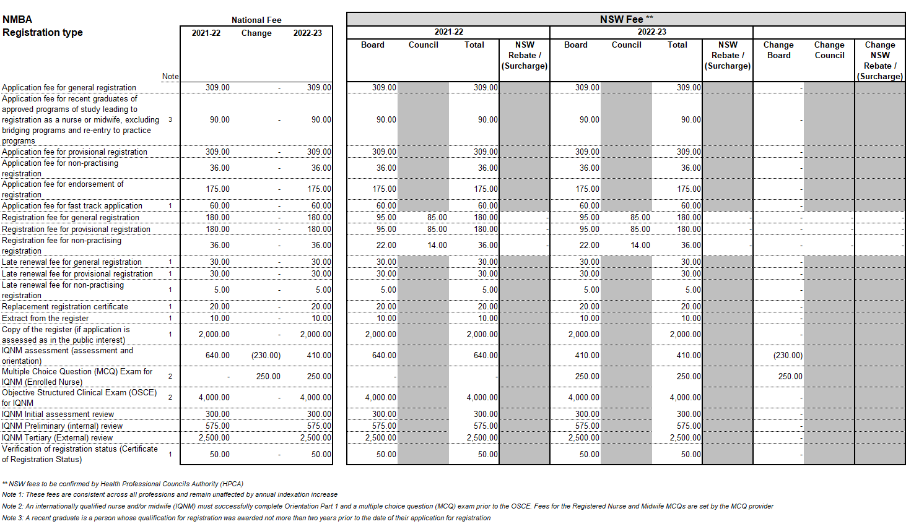

Schedule 5: Summary of National Board’s annual budget
NURSING AND MIDWIFERY BOARD OF AUSTRALIA
Income and expenditure budget and notes
SUMMARY BUDGET 2022/23
Item | $
Income
Registration (see note 1) | 72,510,900
Application | 4,200,000
Interest and Investment Income | 854,394
Late Fees and Fast Track Fees | 325,000
Other | 4,248,000
Total Income | 84,764,163
Expenses
Board and committee (see note 2) | 2,785,972
Legal, tribunal costs and expert advice (see note 3) | 2,749,000
Accreditation (see note 4) | 3,000,100
Office of the Health Ombudsman (Queensland) | 1,470,581
Other direct expenditure (see note 5) | 8,943,536
Indirect expenditure (see note 6) | 62,996,646
Total Expenses | 81,945,835
Net Surplus (Deficit) | 2,818,329

BUDGET NOTES

- Registrant numbers |  | The budget for registration income is based on the following:  - Number of registrants invited to renew at 31 May 2022 renewal period: ……………………………………………………………………….461,304  - Lapse rate of renewals: 3.3%
- Board and committee expenses |  | This covers the meeting costs of the National Board and its committees’ obligations under the National Law.  Costs include sitting fees, travel and accommodation while attending meetings for the Board.
- Legal, tribunal costs, and expert advice |  | These costs are incurred in the management of complaints against practitioners (notifications). The costs do not include the significant Board and committee costs, including sitting fees, related to notifications. These are included in Note 2 above.  Also not included are the material staff costs in each state and territory office relating directly to notifications. These are included in “indirect expenditure” below.
- Accreditation |  | Accreditation expenses include the costs of funding provided to the Australian Nursing and Midwifery Accreditation Council (ANMAC) for accreditation functions. It also includes the costs of the Accreditation Committee which is overseeing the assessment of overseas qualified nurses and midwives.
- Other direct expenditure |  | Costs associated with the Board’s work on registration standards, policies and guidelines. Refer to the 2021/22 work plan for further details.  This includes the following activities:  - costs involved in consultation with the community and the profession  - engagement of consultants necessary to support the Board’s work  - publication of material to guide the profession, such as the Board’s newsletter  - Board member professional development  - policy development and projects  - funding of the external nurses and midwives’ health program, and  - depreciation charges for the IQNM Transformation Program intangible asset.
 | - Indirect expenditure | Indirect expenditure includes Ahpra costs. Ahpra supports the work of the National Boards and committees by employing all staff and providing systems and infrastructure to manage core regulatory (registration, notifications, compliance, accreditation, and professional standards) and support services in eight state and territory offices.  Effective from 1st July 2022, indirect costs are shared by the National Boards using a detailed allocation methodology that has been approved by all National Boards. Allocated costs include salaries, systems and communication, property, and administration costs.  The proportion of Ahpra’s total budgeted costs allocated to the Board for 2022/23 is 31.6%. This allocation has been determined using the following proportions of Ahpra’s costs for each key activity:  - Registration costs $24.7m (33.2%)  - Notification costs $28.1m (28.9%)  - Compliance costs $8.1m (37.3%)  - Transformation Program $2.2k (35.3%).  Ahpra costs also include key strategic initiatives for 2022/23 including the continuation of the Business Transformation program, cultural safety training, cost allocation program, improved cyber security, public register enhancements and other initiatives.

Schedule 6: Performance and reporting
This performance reporting program aims to facilitate the timely and effective delivery of functions under the National Law and the continuous improvement of the partnership between National Board and Ahpra.

There are three separate levels of reporting provided to National Boards outlined in more detail below:

  - Strategic Performance Reports
  - Health Profession Agreement Reports
  - Regulatory Performance Reports

Any additional changes to reporting will be decided through consultation and negotiation with National Boards and Ahpra as part of the annual review of this schedule.

Report | Timing | Content | Frequency
Strategic Performance Reports | Report 1 (Q2) April  Report 2 (Q4) Oct | Strategic Performance Reports (SPRs) inform National Boards and the Agency Management Committee on our progress towards achieving the objectives of the National Scheme Strategy 2020-2025, through an aligned set of measures, targets and initiatives. | Bi-annual
Health Profession Agreement Reports | Report 1: Dec  Report 2: May | Health Profession Agreement (HPA) Reports monitor and report on the health of the partnership between Ahpra and National Boards.  The Reports will be based on the below agreed key result areas:  - Ahpra and National Boards demonstrate our values and behavioural attributes  - Our systems and processes support Ahpra staff, National Boards and their committees to feel safe and included  Ahpra and National Boards have a strong and responsive partnership under the National Law | Bi-annual
Regulatory Performance Reports | Q1: Nov Q2: Feb Q3: May Q4: Aug | Operational reports that measure whole of Ahpra performance across the following areas:  - Reduce patient risk  - Maximise availability of safe and competent practitioners  - Minimise regulatory burden  These reports are supplemented by on-demand dashboards (Power BI) and bi-annual performance seminars.  Progress reporting against specific action plans and/or targets is provided, as agreed by the Regulatory Performance Committee (RPC). | Quarterly

Schedule 7: Equity Framework

Overview Principles of equity
Ahpra and the National Boards work in close partnership to improve the management of equity on behalf of the National Registration and Accreditation Scheme (National Scheme) in the interests of greater cost effectiveness and efficiency to ensure the long-term financial sustainability of the Scheme.

Equity has accumulated both from equity bought into the scheme by National Boards upon the inception of the National Scheme and through subsequent operating surpluses.
Equity serves several important purposes including:

- mitigating against unexpected loss not covered by the National Scheme’s comprehensive insurance
- funding capital and strategic projects that support the effective and efficient operation of Boards and the Scheme
- offsetting the impact to the financial position due to variance in the operating result.

Guiding principles of equity management include:

- joint accountability for the financial resilience and sustainability of the National Scheme, ensuring no Board is unreasonably disadvantaged under the equity approach
- appropriate and efficient use of resources
- use of National Board risk assessments to inform the National Boards’ primary risk pool equity target
- appreciation of the different profession profiles and equity positions
- recognition that the fee strategies for each Board are integral to meeting each board’s individual financial needs
- transparency of process.

Key elements of the Equity Framework include:

- a focus on ensuring sustainable levels of equity across the National Scheme
- two discrete equity pools:
  - Pool one is the National Scheme equity pool
  - Pool two is each National Board’s equity pool
- indicative target equity levels for each National Board, with the Board primary risk pool provision based on the National Board profession risk assessment
- a governance framework and business rules for decision making in relation to equity.

By improving the management of equity, it is anticipated that the following outcomes will be achieved:

- clear accountability and responsibility, improved collaboration, communication and coordination
- increased effectiveness and efficiency
- enhanced trust and confidence in process, oversight and sustainability.

Equity Pools

The National Scheme equity pool serves three purposes:
- funding strategic initiatives with wider benefit to the scheme that are above the budgeted amount
- secondary risk provisioning to mitigate against uninsured loss to Ahpra and the scheme as a whole
- offsetting the impact on the financial position due to variance in the operating result.

The National Board equity pool serves four purposes:
- provision for National Board strategic initiatives
- provision for large case costs
- primary risk provisions
- offsetting the impact to the financial position due to variance in the operating result

