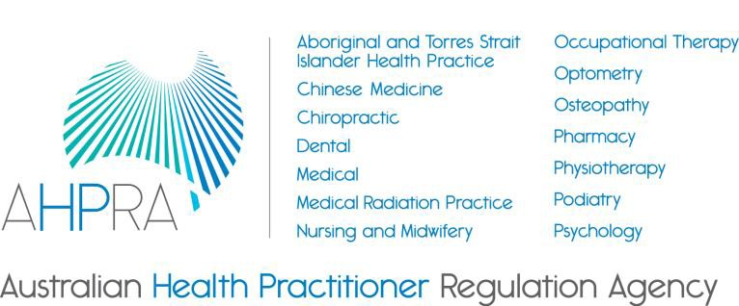

Accreditation Advisory Committee Charter

20 March 2018

Introduction

  - This Charter has been adopted by the Agency Management Committee (the Board) to set out the role of the Accreditation Advisory Committee (the Committee).
  - The Committee’s function is to:

    - provide oversight and leadership on accreditation governance, accountability and transparency issues, and a whole of Scheme perspective on AHPRA’s management of contracts for the performance of the accreditation functions, including financial and reporting matters
    - review AHPRA’s cross-profession analysis of six-monthly reports from accreditation authorities and provide advice to the Board on accreditation governance, accountability and transparency issues identified in the analysis, and
    - provide a forum for discussion, review and advice on significant whole of scheme accreditation issues including governance, accountability and transparency issues.

  - The Committee has no formal delegated power from the Board.
  - This Charter has effect from the date nominated by the Board until it is subsequently amended and approved by the Board.

Purpose

  - The Board has established the Committee to provide advice on significant whole of scheme accreditation issues including the following areas:
    - accreditation governance, accountability and transparency issues affecting the National Registration and Accreditation Scheme
    - the Board and AHPRA’s functions related to accreditation, including financial, contracting and reporting issues
    - AHPRA’s cross-profession analysis of six-monthly reports from accreditation authorities, and
    - accreditation governance, accountability and transparency issues identified in AHPRA’s cross- profession analysis of six-monthly reports from accreditation authorities

  - The Committee must follow a lawful direction given to it by the Board, and those directions override all provisions of this Charter.

  - In order to ensure that it provides effective and timely advice to the Board, the Committee will:

    - review and advise on key documents relating to AHPRA’s management of contracts for the performance of the accreditation functions, including financial and reporting matters
    - report to the Board on any issue identified that may amount to a significant risk to the Scheme or that would benefit from the Board’s specific consideration
    - consider AHPRA’s cross-profession analysis of six-monthly reports from accreditation authorities and provide advice to the Board on accreditation governance, accountability and transparency issues identified in the analysis as needed
    - report annually to the Board on the performance of the Committee, and
Australian Health Practitioner Regulation Agency
G.P.O. Box 9958 | Melbourne VIC 3001 | www.ahpra.gov.au

- report to the Board following each meeting.

Members of the Committee

  - Members of the Committee are appointed by the Board for a term not exceeding three years. Members may be re-appointed for two additional terms.
  - The Committee will consist of up to 6 members including:

    - up to three members of the Board
    - a chair of a National Board
    - a community member of a National Board, and
    - an external expert in accreditation. “external” means an individual who is not an officebearer, employee or agent of an entity within the National Scheme including national boards, accreditation authorities and AHPRA.

  - The Chair is appointed by the Board and must also be a member of the Board.

  - Secretariat and professional support will be provided by AHPRA.
  - The Board will consider the range and mix of skills necessary to enable the Committee to fulfil its function. The Board recognises the following skills as important for the success of the committee and will look to make sure the Committee’s membership reflects these competencies:
    - A sound understanding of National Registration and Accreditation Scheme governance and the core functions of AHPRA
    - Sound knowledge and experience of accreditation within the National Registration and Accreditation Scheme, and
    - Experience in health education or accreditation of health education

  - The Board can fill a casual vacancy in the Committee and must ensure that the Committee has a Chair at all times.

Meetings of the Committee

  - The Committee will hold at least four scheduled meetings per calendar year.
  - In addition to the scheduled meetings, a meeting of the Committee must be held if requested by either:
    - the Board, or
    - the CEO of AHPRA.
  - Three members of the Committee, two of whom must also be members of the Board, are required for a quorum.
  - The Committee, through the AHPRA CEO, may request at any of its meetings the provision of:

    - relevant data or information
    - independent professional advice, and/or
    - the attendance of any member of AHPRA staff, the Co-Chair of the Accreditation Liaison Group and/or additional external expertise such as the Tertiary Education Quality and Standards Agency and the Australian Commission on Safety and Quality in Healthcare.

Reporting to the Board

  - The Committee must submit the minutes of each meeting to the next possible meeting of the Board and the Chair will provide a verbal update after each meeting.
  - The Committee will conduct a review of its activities prior to the end of each financial year and provide a summary of the review to the next meeting of the Board.
  - The Committee will produce a report annually of its activities for consideration by the Board and circulation to National Boards.

  - The Committee must also provide any reports requested of it by the Board.

Accountability and Review

  - The Board will review this Charter annually.

