Guidelines for mandatory notifications
March 2014
About the National Boards and AHPRA

The 14 National Boards regulating registered health practitioners in Australia are responsible for registering practitioners and students (except for in psychology, which has provisional psychologists), setting the standards that practitioners must meet, and managing notifications (complaints) about the health, conduct or performance of practitioners.

The Australian Health Practitioner Regulation Agency (AHPRA) works in partnership with the National Boards to implement the National Registration and Accreditation Scheme, under the Health Practitioner Regulation National Law, as in force in each state and territory (the National Law).

The core role of the National Boards and AHPRA is to protect the public.
Overview
These guidelines have been developed jointly by the National Boards under section 39 of the Health Practitioner Regulation National Law as in force in each state and territory (the National Law). The guidelines are developed to provide direction to registered health practitioners, employers of practitioners and education providers about the requirements for mandatory notifications under the National Law.
The inclusion of mandatory notification requirements in the National Law is an important policy initiative for public protection.
The relevant sections of the National Law are attached.
Who needs to use these guidelines?
These guidelines are relevant to:
- health practitioners registered under the National Law
- employers of practitioners, and
- education providers.
Students who are registered in a health profession under the National Law should be familiar with these guidelines. Although the National Law does not require a student to make a mandatory notification, a notification can be made about an impaired student.
Summary of guidelines
These guidelines explain the requirements for registered health practitioners, employers of practitioners and education providers to make mandatory notifications under the National Law to prevent the public being placed at risk of harm.
The threshold to be met to trigger a mandatory notification in relation to a practitioner is high. The practitioner or employer must have first formed a reasonable belief that the behaviour constitutes notifiable conduct or a notifiable impairment or, in the case of an education provider, a notifiable impairment (see section 3 for the definition of ‘notifiable conduct’ and Appendix A for the definition of ‘impairment’).
Making a mandatory notification is a serious step to prevent the public from being placed at risk of harm and should only be taken on sufficient grounds. The guidelines explain when these grounds are likely to arise.
Importantly, the obligation to make a mandatory notification applies to the conduct or impairment of all practitioners, not just those within the practitioner’s own health profession.
These guidelines also address the role of the Australian Health Practitioner Regulation Agency (AHPRA) as the body for receiving notifications and referring them to the relevant National Board.

- Introduction
The National Law requires practitioners, employers and education providers to report ‘notifiable conduct’, as defined in section 140 of the National Law, to AHPRA in order to prevent the public being placed at risk of harm.
These guidelines explain how the Boards will interpret these mandatory notification requirements. They will help practitioners, employers and education providers understand how to work with these requirements; that is, whether they must make a notification about a practitioner’s conduct and when.
The threshold to be met to trigger the requirement to report notifiable conduct in relation to a practitioner is high; and the practitioner or employer must have first formed a reasonable belief that the behaviour constitutes notifiable conduct.
The aim of the mandatory notification requirements is to prevent the public from being placed at risk of harm. The intention is that practitioners notify AHPRA if they believe that another practitioner has behaved in a way which presents a serious risk to the public. The requirements focus on serious instances of sub-standard practice or conduct by practitioners, or serious cases of impairment, that could place members of the public at risk. For students, the requirements focus on serious cases of impairment of students.
That is, the requirements focus on behaviour that puts the public at risk of harm, rather than not liking the way someone else does something or feeling that they could do their job better.
Similarly, if the only risk is to the practitioner alone, and there is no risk to the public, the threshold for making a mandatory notification would not be reached. For example, in a case where the risk is clearly addressed by being appropriately managed through treatment and the practitioner is known to be fully compliant with that, mandatory notification would not be required. Conversely, a mandatory notification is required if the risk to the public is not mitigated by treatment of the practitioner or in some other way.
Voluntary notifications
The National Law also provides for voluntary notifications for behaviour that presents a risk but does not meet the threshold for notifiable conduct or for notifications made by individuals who are not subject to the mandatory notification obligations such as patients or clients (see ss. 144 and 145 of the National Law).

Protection for people making a notification
The National Law protects practitioners, employers and education providers who make notifications in good faith under the National Law. ‘Good faith’ is not defined in the National Law so has its ordinary meaning of being well-intentioned or without malice. Section 237 provides protection from civil, criminal and administrative liability, including defamation, for people making notifications in good faith. The National Law clarifies that making a notification is not a breach of professional etiquette or ethics or a departure from accepted standards of professional conduct. These provisions protect practitioners making mandatory notifications from legal liability and reinforce that making mandatory notifications under the National Law is consistent with professional conduct and a practitioner’s ethical responsibilities. Legally mandated notification requirements override privacy laws. Practitioners should be aware that if they make notifications that are frivolous, vexatious or not in good faith, they may be subject to conduct action.

- General obligations
The obligation is on any practitioner or employer who forms a reasonable belief that another practitioner has engaged in notifiable conduct to make a report to AHPRA as soon as practicable. The definition of ‘notifiable conduct’ is set out in section 140 of the National Law (also refer to section 3 of these guidelines for more information on notifiable conduct). In this context, the word ‘practicable’ has its ordinary meaning of “feasible” or “possible”.
The mandatory notification obligation applies to all practitioners and employers of practitioners in relation to the notifiable conduct of practitioners. The obligation applies to practitioners in all registered health professions, not just those in the same health profession as the practitioner. It also applies where the notifying practitioner is also the treating practitioner for a practitioner, except in Western Australia and Queensland in certain circumstances (see Section 4 Exceptions to the requirements of practitioners to make a mandatory notification of these guidelines for details).
There is also a mandatory obligation for education providers and practitioners to report a student with an impairment that may place the public at substantial risk of harm.
While the mandatory reporting provisions in the National Law are an important policy change, the duties covered in them are consistent with general ethical practice and professional obligations. In addition to their legal obligations with respect to mandatory reporting, practitioners are also under an ethical obligation to notify concerns about a practitioner, in accordance with the broad ethical framework set out in the health profession’s code of conduct (see the code of conduct and the voluntary reporting provisions of the National Law). More information about making a voluntary notification is published on the National Boards’ and AHPRA’s websites.
There are some exceptions to the requirement for practitioners to notify AHPRA of notifiable conduct, which are discussed at Section 4 Exceptions to the requirement of practitioners to make a mandatory notification.
These guidelines do not affect other mandatory reporting requirements that may be established in separate legislation, for example requirements to report child abuse.
What is a reasonable belief?
For practitioners reporting notifiable conduct, a ‘reasonable belief’ must be formed in the course of practising the profession. The following principles are drawn from legal cases which have considered the meaning of reasonable belief.
- A belief is a state of mind.
- A reasonable belief is a belief based on reasonable grounds.
- A belief is based on reasonable grounds when:
- all known considerations relevant to the formation of a belief are taken into account including matters of opinion, and
- those known considerations are objectively assessed.
A just and fair judgement that reasonable grounds exist in support of a belief can be made when all known considerations are taken into account and objectively assessed.
A reasonable belief requires a stronger level of knowledge than a mere suspicion. Generally it would involve direct knowledge or observation of the behaviour which gives rise to the notification, or, in the case of an employer, it could also involve a report from a reliable source or sources. Mere speculation, rumours, gossip or innuendo are not enough to form a reasonable belief.
A reasonable belief has an objective element – that there are facts which could cause the belief in a reasonable person; and a subjective element – that the person making the notification actually has that belief.
A notification should be based on personal knowledge of facts or circumstances that are reasonably trustworthy and that would justify a person of average caution, acting in good faith, to believe that notifiable conduct has occurred or that a notifiable impairment exists. Conclusive proof is not needed. The professional background, experience and expertise of a practitioner, employer or education provider will also be relevant in forming a reasonable belief.
The most likely example of where a practitioner or employer would form a reasonable belief is where the person directly observes notifiable conduct, or, in relation to an education provider, observes the behaviour of an impaired student. Where a practitioner is told about notifiable conduct that another practitioner or patient has directly experienced or observed, the person with most direct knowledge about the notifiable conduct should generally be encouraged to make a notification themselves.

What is ‘the public’?
Several of the mandatory notification provisions refer to ‘the public being placed at risk of harm’. In the context of notifications, ‘the public’ can be interpreted as persons that access the practitioner’s regulated health services or the wider community which could potentially have been placed at risk of harm by the practitioner’s services.
- Notifiable conduct
Section 140 of the National Law defines ‘notifiable conduct’ as when a practitioner has:
‘(a) practised the practitioner’s profession while intoxicated by alcohol or drugs; or
(b) engaged in sexual misconduct in connection with the practice of the practitioner’s profession; or
(c) placed the public at risk of substantial harm in the practitioner’s practice of the profession because the practitioner has an impairment; or
(d) placed the public at risk of harm because the practitioner has practised the profession in a way that constitutes a significant departure from accepted professional standards.’
The following sections of the guidelines discuss these types of notifiable conduct, followed by the exceptions. The guidelines are only examples of decision making processes, so practitioners, employers and education providers should check the exceptions to make sure they do not apply.
If a practitioner engages in more than one type of notifiable conduct, each type is required to be notified.
Practise while intoxicated by alcohol or drugs (section 140(a))
The requirement to make a mandatory notification is triggered by a practitioner practising their profession while intoxicated by alcohol or drugs. The word ‘intoxicated’ is not defined in the National Law, so the word has its ordinary meaning of ‘under the influence of alcohol or drugs’.
The Boards will consider a practitioner to be intoxicated where their capacity to exercise reasonable care and skill in the practice of the health profession is impaired or adversely affected as a result of being under the influence of drugs or alcohol. The key issue is that the practitioner has practised whilst intoxicated, regardless of the time that the drugs or alcohol were consumed.
The National Law does not require mandatory notification of a practitioner who is intoxicated when they are not practising their health profession (that is, in their private life), unless the intoxication triggers another ground for mandatory notification.

Decision guide – notifying intoxication
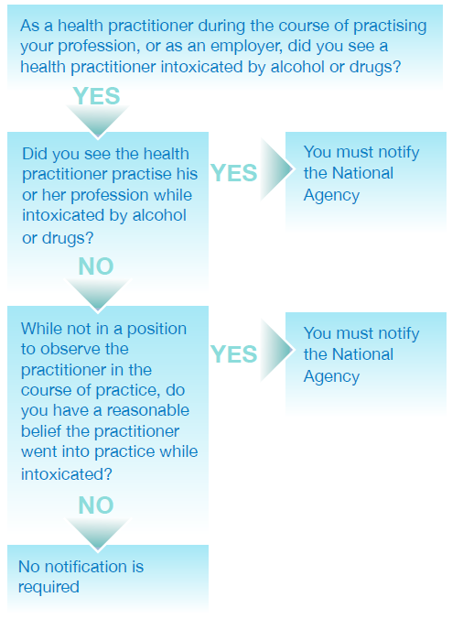
Sexual misconduct in connection with the practice of the practitioner’s profession (section 140(b))
Section 140(b) relates to sexual misconduct in connection with the practice of the practitioner’s health profession; that is, in relation to persons under the practitioner’s care or linked to the practitioner’s practice of their health profession.
Engaging in sexual activity with a current patient or client will constitute sexual misconduct in connection with the practice of the practitioner’s health profession, regardless of whether the patient or client consented to the activity or not. This is because of the power imbalance between practitioners and their patients or clients.
Sexual misconduct also includes making sexual remarks, touching patients or clients in a sexual way, or engaging in sexual behaviour in front of a patient or client. Engaging in sexual activity with a person who is closely related to a patient or client under the practitioner’s care may also constitute misconduct. In some cases, someone who is closely related to a patient or client may also be considered a patient or client; for example, the parent of a child patient or client.
Engaging in sexual activity with a person formerly under a practitioner’s care (i.e. after the termination of the practitioner-patient/client relationship) may also constitute sexual misconduct. Relevant factors will include the cultural context, the vulnerability of the patient or client due to issues such as age, capacity and/or health conditions; the extent of the professional relationships; for example, a one-off treatment in an emergency department compared to a long term program of treatment; and the length of time since the practitioner-patient/client relationship ceased.

Decision guide – notifying sexual misconduct
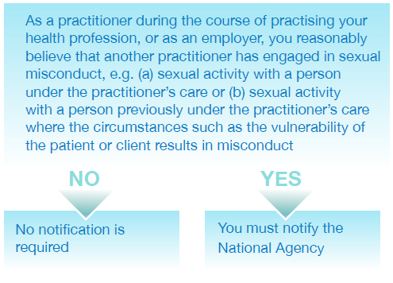
Note: Voluntary notifications can be made.
Placing the public at risk of substantial harm because of an impairment (section 140(c))
Section 5 of the National Law defines ‘impairment’ for a practitioner or an applicant for registration in a health profession as meaning a person has ‘a physical or mental impairment, disability, condition or disorder (including substance abuse or dependence) that detrimentally affects or is likely to detrimentally affect the person’s capacity to practise the profession.’
To trigger this notification, a practitioner must have placed the public at risk of substantial harm . ‘Substantial harm’ has its ordinary meaning; that is, considerable harm such as a failure to correctly or appropriately diagnose or treat because of the impairment. For example, a practitioner who has an illness which causes cognitive impairment so they cannot practise effectively would require a mandatory notification. However, a practitioner who has a blood borne virus who practises appropriately and safely in light of their condition and complies with any registration standards or guidelines and professional standards and protocols would not trigger a notification.
The context of the practitioner’s work is also relevant. If registered health practitioners, employers and education providers are aware that the employer knows of the practitioner’s impairment, and has put safeguards in place such as monitoring and supervision, this may reduce or prevent the risk of substantial harm.
Decision guide – notifying impairment in relation to a practitioner 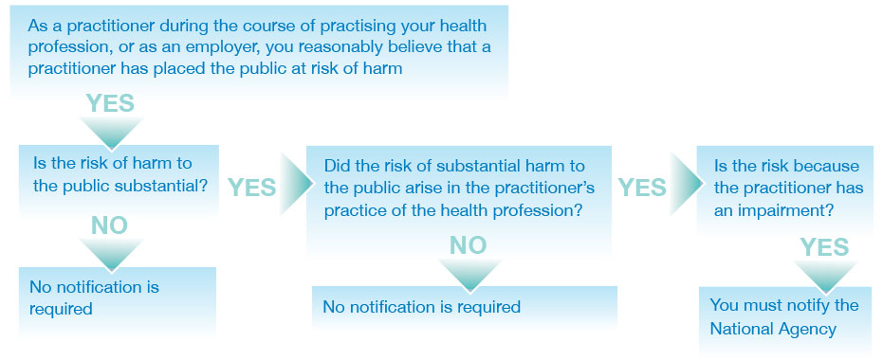
* for notification of student impairment, please see Education Providers Section 6 of guidelines
Placing the public at risk of harm because of practice in a way that constitutes a significant departure from accepted professional standards (section 140(d))
The term ‘accepted professional standards’ requires knowledge of the professional standards that are accepted within the health profession and a judgement about whether there has been a significant departure from them. This judgement may be easier for other members of the practitioner’s health profession.
Mandatory notifications about a practitioner from another health profession are most likely to arise in a team environment where different health professions are working closely together and have a good understanding of the contribution of each practitioner; for example, a surgical or mental health team.
The difference from accepted professional standards must be significant. The term ‘significant’ means important, or of consequence (Macquarie concise dictionary). Professional standards cover not only clinical skills but also other standards of professional behaviour. A significant departure is one which is serious and would be obvious to any reasonable practitioner.
The notifiable conduct of the practitioner must place the public at risk of harm as well as being a significant departure from accepted professional standards before a notification is required. However, the risk of harm just needs to be present - it does not need to be a substantial risk, as long as the practitioner’s practice involves a significant departure from accepted professional standards. For example, a clear breach of the health profession’s code of conduct which places the public at risk of harm would be enough.
This provision is not meant to trigger notifications based on different professional standards within a health profession, provided the standards are accepted within the health profession; that is, by a reasonable proportion of practitioners. For example, if one practitioner uses a different standard to another practitioner, but both are accepted standards within the particular health profession, this would not qualify as a case of notifiable conduct. Similarly, if a practitioner is engaged in innovative practice but within accepted professional standards, it would not trigger the requirement to report.

Decision guide – significant departure from accepted professional standards
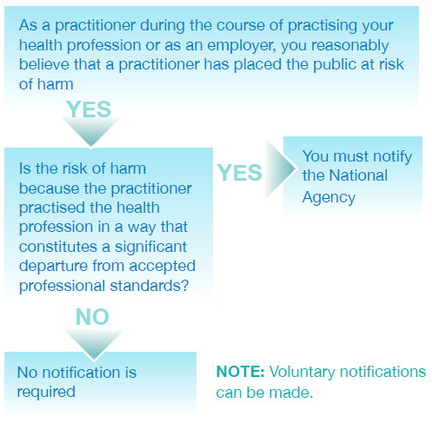
- Exceptions to the requirement of practitioners to make a mandatory notification
There are particular exceptions to the requirement to make a mandatory notification for practitioners. The exceptions relate to the circumstances in which the practitioner forms the reasonable belief in misconduct or impairment. They arise where the practitioner who would be required to make the notification:
- is employed or engaged by a professional indemnity insurer, and forms the belief because of a disclosure in the course of a legal proceeding or the provision of legal advice arising from the insurance policy
- forms the belief while providing advice about legal proceedings or the preparation of legal advice
- is exercising functions as a member of a quality assurance committee, council or other similar body approved or authorised under legislation which prohibits the disclosure of the information
- reasonably believes that someone else has already made a notification,
- is a treating practitioner, practising in Western Australia, or
- is a treating practitioner, practising in Queensland in certain circumstances
Practitioners in Western Australia are not required to make a mandatory notification when their reasonable belief about misconduct or impairment is formed in the course of providing health services to a health practitioner or student. However, practitioners in Western Australia continue to have a professional and ethical obligation to protect and promote public health and safety. They may therefore make a voluntary notification or may encourage the practitioner or student they are treating to self-report.
From the commencement of the Health Ombudsman Act 2013, practitioners in Queensland are not required to make a mandatory notification when their reasonable belief is formed as a result of providing a health service to a health practitioner, where the practitioner providing the service reasonably believes that the notifiable conduct relates to an impairment which will not place the public at substantial risk of harm and is not professional misconduct. In Queensland, mandatory notifications must be made to the Health Ombudsman, rather than AHPRA. The Ombudsman must advise AHPRA about the notification in certain circumstances.
Practitioners should refer to Appendix A of these Guidelines for an extract of the relevant legislation; see section 141 if it is possible one of these exceptions might apply.
- Mandatory notifications about impaired students
Education providers are also required, under section 143 of the National Law, to make mandatory notifications in relation to students, if the provider reasonably believes:
- a student enrolled with the provider has an impairment that, in the course of the student undertaking clinical training, may place the public at substantial risk of harm, or
- a student for whom the provider has arranged clinical training has an impairment that, in the course of the student undertaking the clinical training, may place the public at substantial risk of harm.
Practitioners are required to make a mandatory notification in relation to a student if the practitioner reasonably believes that a student has an impairment that, in the course of the student undertaking clinical training, may place the public at substantial risk of harm (section141(1)(b)).
In all cases, the student’s impairment must place the public at substantial, or considerable, risk of harm in the course of clinical training.
In relation to a student, ‘impairment’ is defined under section 5 of the National Law to mean the student ‘has a physical or mental impairment, disability, condition or disorder (including substance abuse or dependence) that detrimentally affects or is likely to detrimentally affect the student’s capacity to undertake clinical training —
(i) as part of the approved program of study in which the student is enrolled; or
(ii) arranged by an education provider.’
An education provider who does not notify AHPRA as required by section 143 does not commit an offence. However, the National Board that registered the student must publish details of the failure to notify on the Board’s website and AHPRA may, on the recommendation of the National Board, include a statement about the failure in AHPRA’s annual report.
Decision guide – student impairment
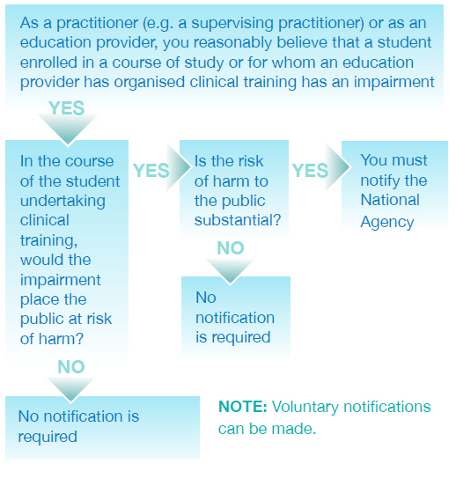
- Consequences of failure to notify
Registered health practitioners
Although there are no penalties prescribed under the National Law for a practitioner who fails to make a mandatory notification, any practitioner who fails to make a mandatory notification when required may be subject to health, conduct or performance action.
Employers of practitioners
There are also consequences for an employer who fails to notify AHPRA of notifiable conduct as required by section 142 of the National Law.
If AHPRA becomes aware of such a failure, it must give a written report about the failure to the responsible Minister for the jurisdiction in which the notifiable conduct occurred. As soon as practicable after receiving such a report, the responsible Minister must report the employer’s failure to notify to a health complaints entity, the employer’s licensing authority or another appropriate entity in that participating jurisdiction.
Importantly, the requirement to make a mandatory notification does not reduce an employer’s responsibility to manage the practitioner employee’s performance and protect the public from being placed at risk of harm. However, if an employer has a reasonable belief that a practitioner has behaved in a way that constitutes notifiable conduct, then the employer must notify, regardless of whether steps are put in place to prevent recurrence of the conduct or impairment, or whether the practitioner subsequently leaves the employment.
- How a notification is made (section 146)
Under the National Law, notifications are be made to AHPRA, which receives notifications and refers them to the relevant National Board. The notification must include the basis for making the notification; that is, practitioners, employers and education providers must say what the notification is about. It may assist practitioners, employers and education providers in making a notification if they have documented the reasons for the notification, including the date and time that they noticed the conduct or impairment.
To make a notification verbally, practitioners, employers and education providers may ring 1300 419 495 or go to any of the State and Territory AHPRA office.
To make a notification in writing, go to the Notifications and Outcomes section of the AHPRA website at www.ahpra.gov.au, download a notification form and post your completed form to AHPRA, GPO Box 9958 in your capital city.
If you are unsure about whether to make a mandatory notification, you may wish to seek advice from your insurer and/or professional association.

Date of issue: 17 March 2014
Date of review: These guidelines will be reviewed from time to time as required. This will generally be at least every three years
Last reviewed: September 2013

Appendix A – Extract of relevant provisions from National Law
Content is taken directly from legislation so is not included here.

These changes are made in the Health Ombudsman Act 2013 (Qld), which was assented to on 29 August 2013 and will commence on a day to be fixed by proclamation. These Guidelines will then be updated to reflect the commencement.

